**To Log a Bug**

Go to this link:

1. <https://github.com/cs340tabyu/CatanBugTracker/issues>
2. 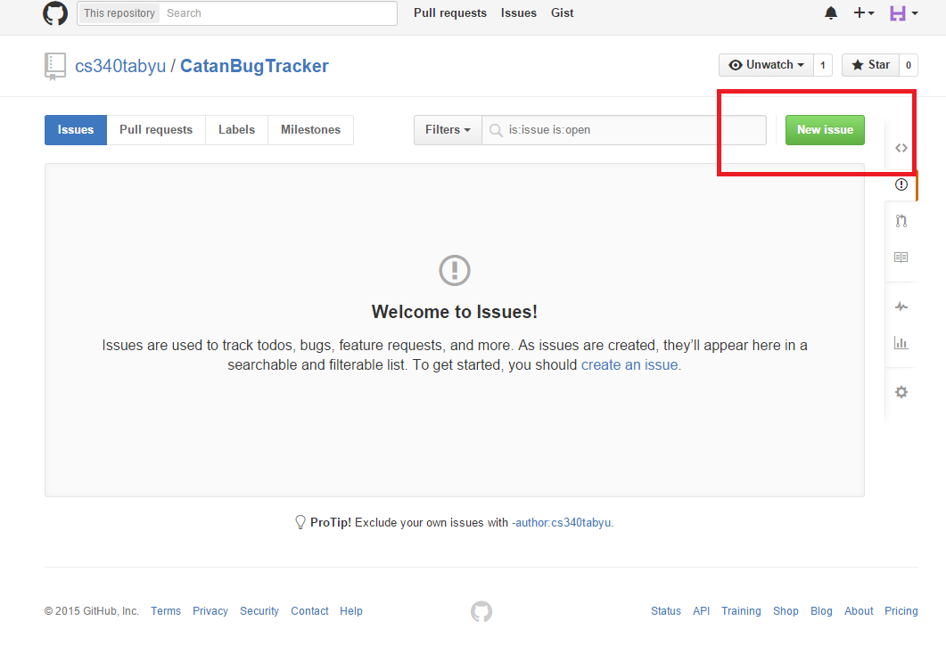Click on “New Issue”
3. Enter a title and description. This includes the steps to reproduce the bug. Screen shots can be attached as well. (The title in the title input, the description in the comment input)

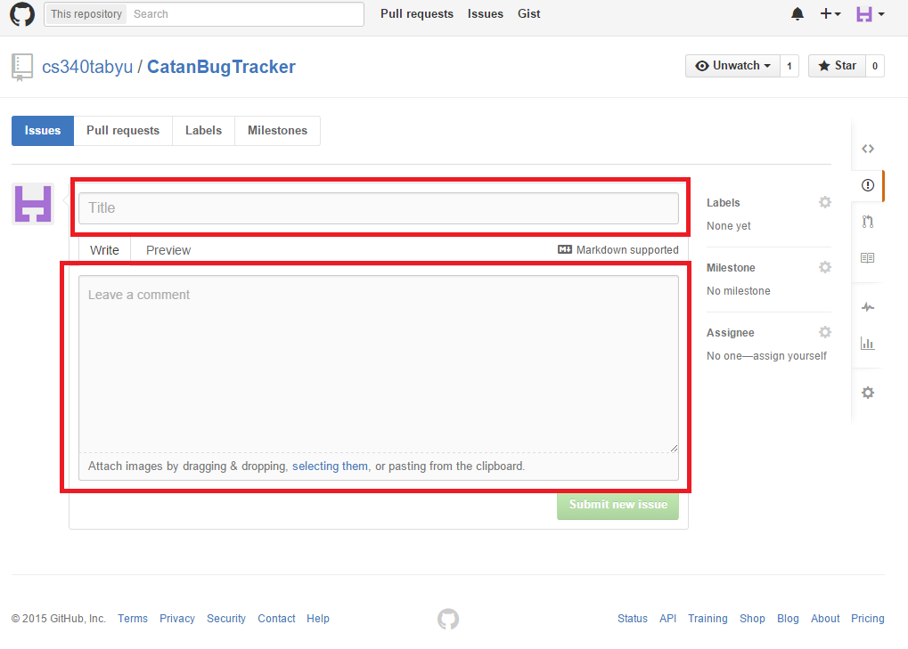

1. Select the Labels option on the right

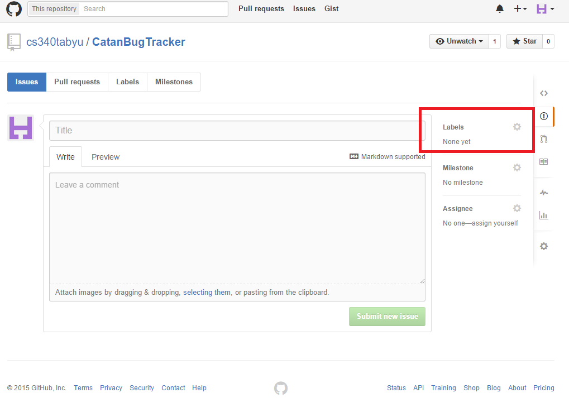

1. 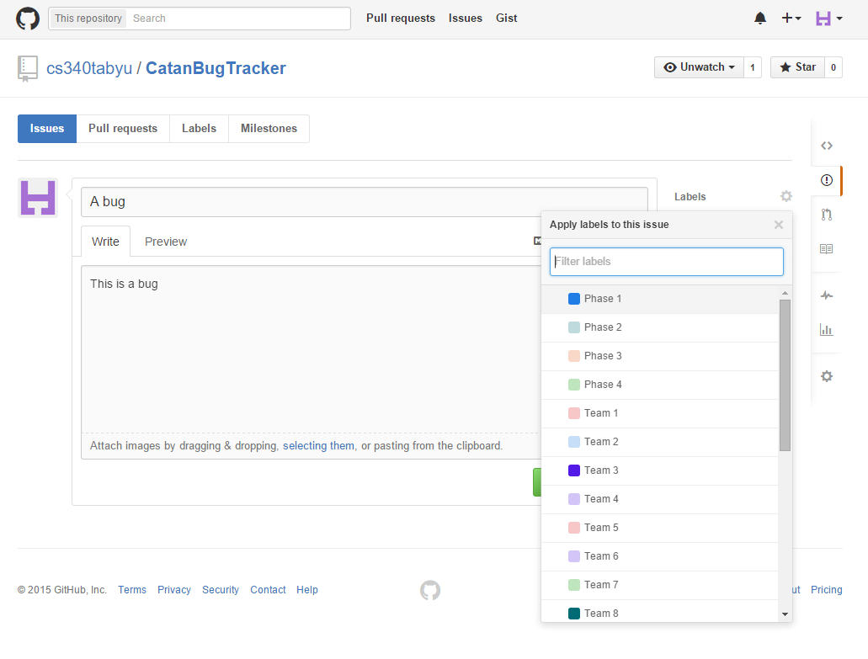A pop down will appear
2. 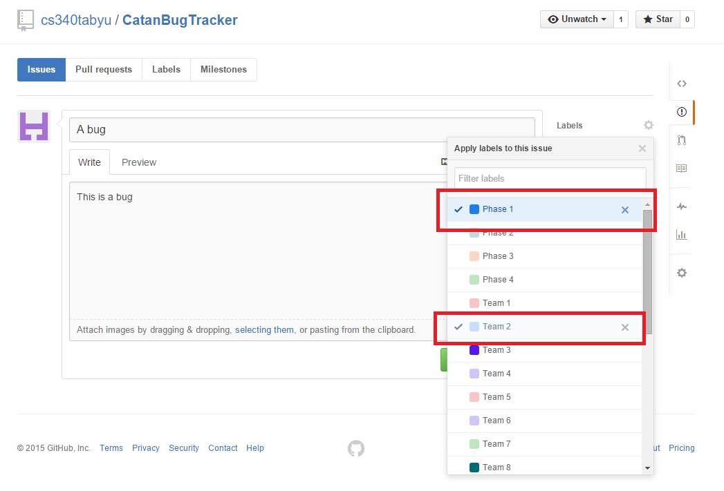Select the phase and team this bug should be reported to. (Not your team, the team who you are testing)
3. X out of the label drop down, and then submit the bug

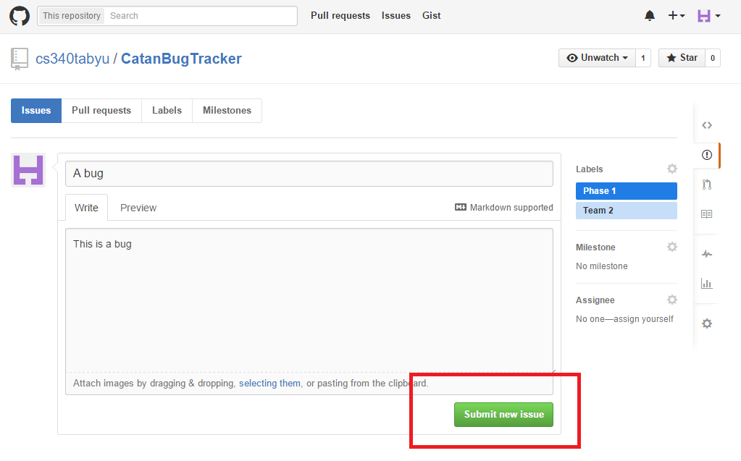

1. Boom that’s it!

**Scroll to the next page to view the bugs logged against you**

**To view the bugs logged against you:**

Go to this link:

1. <https://github.com/cs340tabyu/CatanBugTracker/issues>
2. 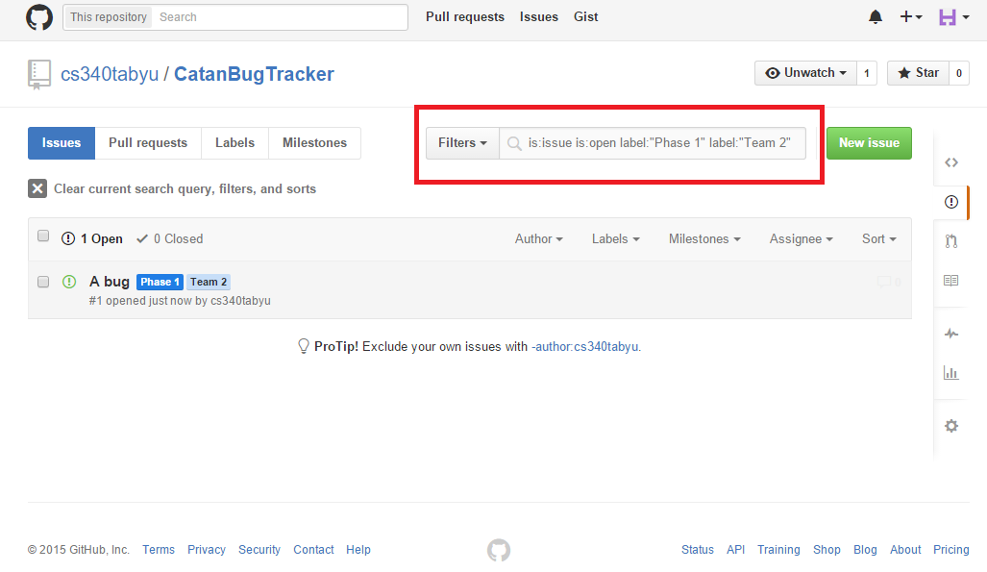In the search box enter [**label:”Phase X” label:”Team Y”**], where X is the phase you want to see and Y is your team number. **Press enter**
3. 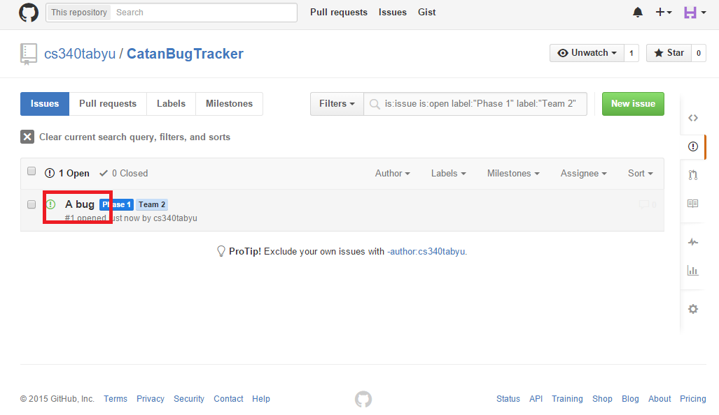Click the name of the bug you want details about
4. Once you have fixed the bug, or have otherwise found a resolution to the bug click the “Close issue” button.

